Figure captions

Fig. 1.

Fig. 2.

Fig. 3.

Fig. 4.

Fig. 1.

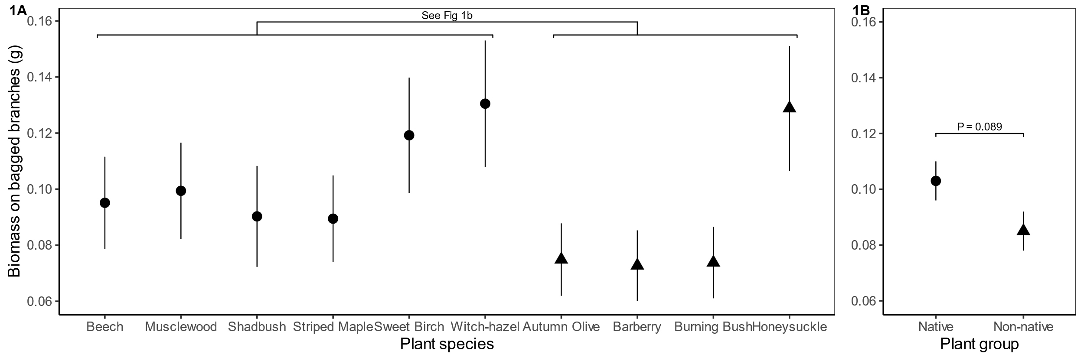

Fig 2.

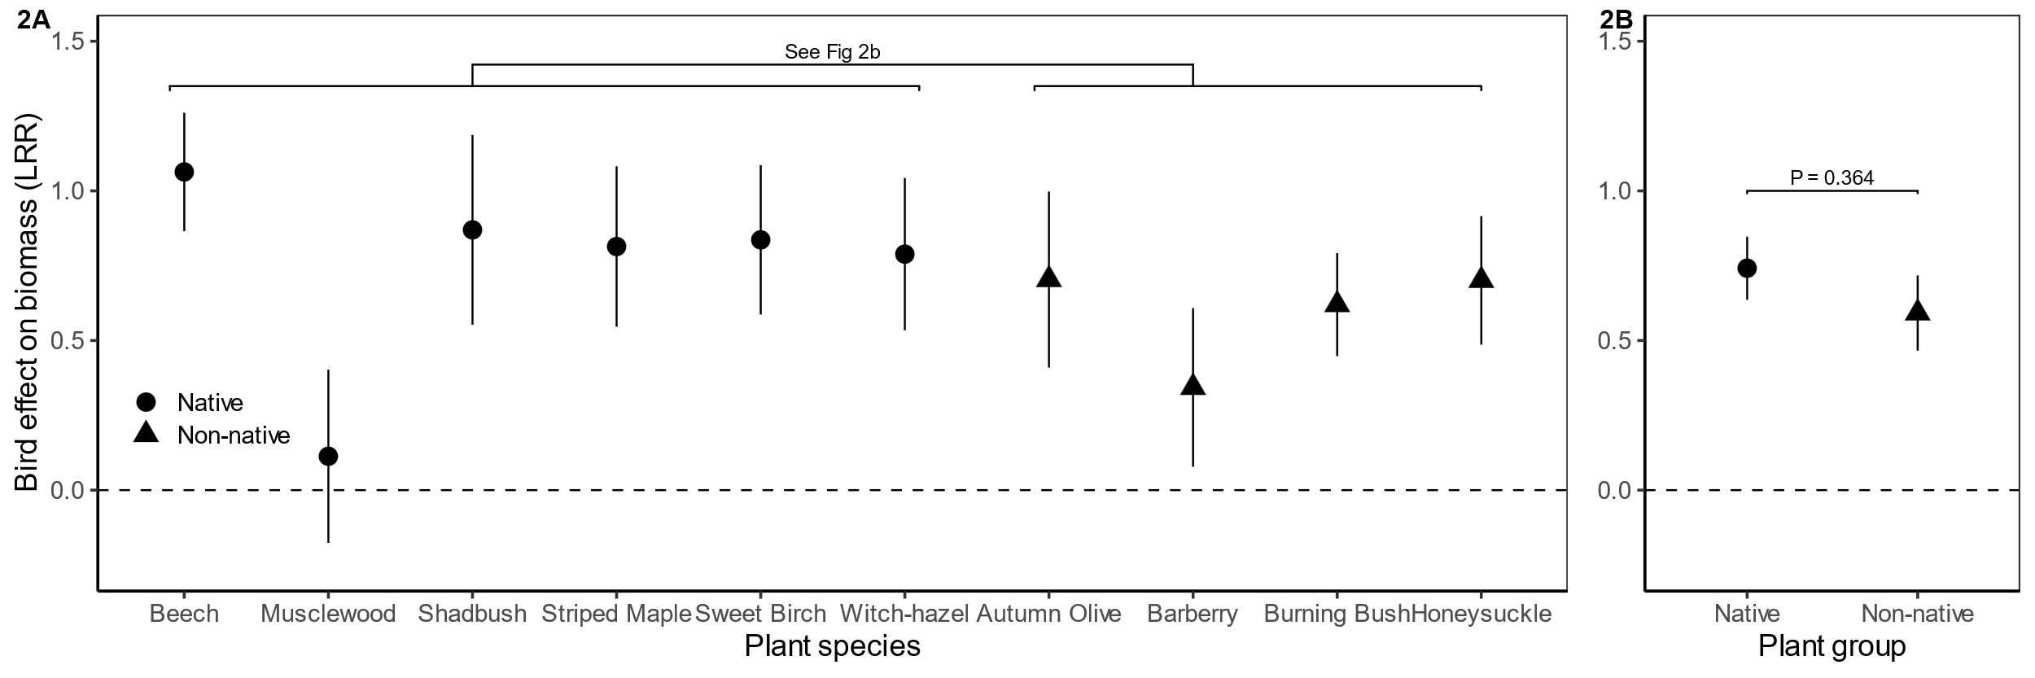

Fig 3.

Fig 4.

